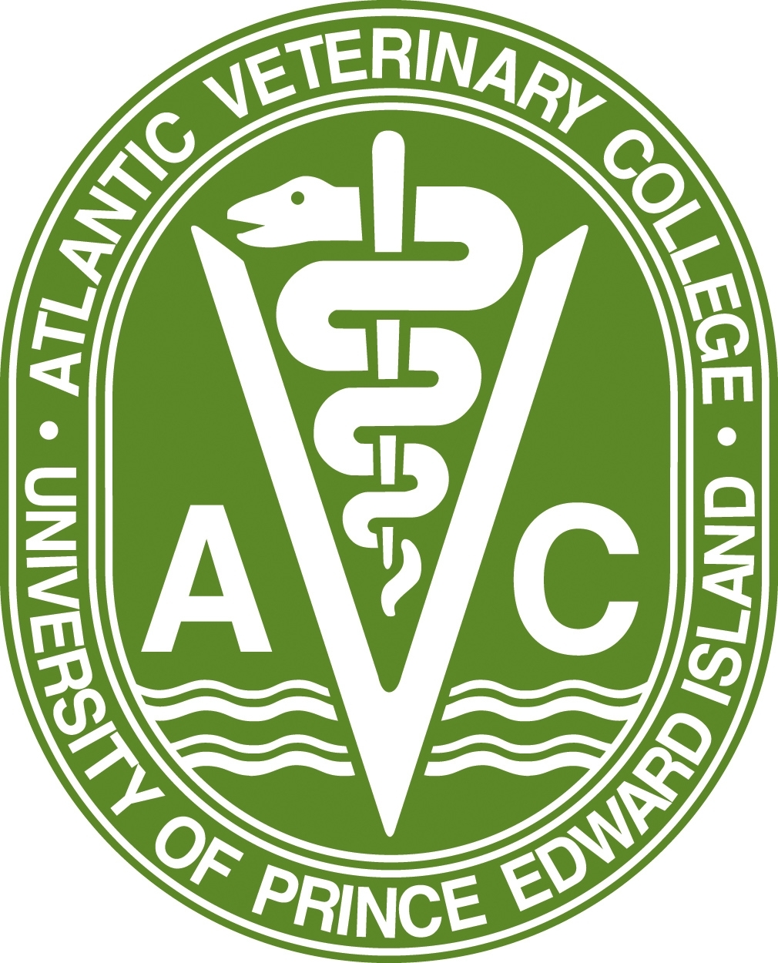

**University of Prince Edward Island - Atlantic Veterinary College**

**ATLANTIC CANADIAN APPLICANT**

**DOCTOR OF VETERINARY MEDICINE PROGRAM**

**ANIMAL AND VETERINARY EXPERIENCE SUBMISSION FORM**

|  |
| --- |
|  |

|  |  |
| --- | --- |
| **Last Name:** | **First Name**: |
| **Email:** | **Phone:** |
| **Instructions:**   1. **Download the form to your personal electronic device (PED).** 2. **Review the guidelines provided below.** 3. **Enter the details of your veterinary and animal experiences in the tables provided and save the file to your PED.** 4. **When you have completed and reviewed all entries, upload the file from your PED to your UPEI online application.** | |
| All DVM applicants are required to submit structured descriptions of their veterinary and animal experiences prior to application to the DVM program. The goal of these experiences is to provide applicants with insight into the breadth of the veterinary profession and assist them in making an informed career choice.  **Veterinary experience** must be obtained under the supervision of a qualified veterinarian working in the field of veterinary medicine. It may be paid or voluntary. Experiences may involve general or referral clinical practice and/or provision of veterinary care to animals in research laboratories, zoos, animal shelters, and animal rehabilitation facilities. Experience with veterinarians working in non-clinical capacities including regulatory or public health agencies is also acceptable. Veterinary experience should involve direct interactions with one or more veterinarians working in the field and should not be restricted to reception or administrative duties only. Applicants should be advised that there is no minimum number of hours required for application, however, it is advised to attain as many hours with as many different species (i.e. swine, cows, horses, exotic pets, dogs, cats, etc.) as possible. In most cases, veterinary experience within North America is recommended.  **Animal experience** may involve working with livestock, breeding or showing animals, working in a pet store, participating in equestrian activities, or any other animal-related hobby or experience where a veterinarian is not always present and/or does not provide direct supervision. It may be paid or voluntary. Please note that animal experience for the purposes of application to the DVM program does not include pet ownership.  Details about each experience should be entered individually in the tables provided. Please complete all sections of the table and note the following:   1. Start and end dates for all veterinary and animal experiences must be within the **five (5) year period preceding October 15 of the year of application.** 2. The maximum number of experiences permitted is 10. Additional experiences beyond 10 will not be evaluated. 3. Upload all pages of the form even if you have fewer than 10 experiences to submit. | |

|  |  |  |  |  |  |  |  |  |
| --- | --- | --- | --- | --- | --- | --- | --- | --- |
| 1. **Experience Type *(check one)*: Veterinary**  **Animal** | | | | | | | | |
| Recognition Type *(check all that apply)*: Compensated  Volunteer | | | | | | | | |
| Position Title: | | | | | | | | |
| Organization or Employer Name: | | | | | | | | |
| Organization or Employer Address: | | | | | | | | |
| Supervisor Name: | | | | | Supervisor Title: | | | |
| Supervisor Email: | | | | | Supervisor Phone: (   )   - | | | |
| Permission to Contact Supervisor? *(check one)* Yes  No | | | | | | | | |
| Start Date *(mm/dd/yyyy)*:   /  / | | | | | End Date *(mm/dd/yyyy)*:   /  / | | | |
| Status *(check all that apply):*  Temporary  Part-Time  Full-Time | | | | | | | | |
| Hours per Week: | | | Total Weeks: | | | | Total Hours: | |
| Animal Types *(check all that apply)*: | | | | | | | | |
| Small  Animals | Food  Animals | Horses | | Zoo Animals/ Wildlife | | Exotic Animals/ Birds | | Other  Specify: |
| Experience Details: | | | | | | | | |

|  |  |  |  |  |  |  |  |  |
| --- | --- | --- | --- | --- | --- | --- | --- | --- |
| 1. **Experience Type *(check one)*: Veterinary  Animal** | | | | | | | | |
| Recognition Type *(check all that apply)*: Compensated  Volunteer | | | | | | | | |
| Position Title: | | | | | | | | |
| Organization or Employer Name: | | | | | | | | |
| Organization or Employer Address: | | | | | | | | |
| Supervisor Name: | | | | | Supervisor Title: | | | |
| Supervisor Email: | | | | | Supervisor Phone: (   )   - | | | |
| Permission to Contact Supervisor? *(check one)* Yes  No | | | | | | | | |
| Start Date *(mm/dd/yyyy)*:   /  / | | | | | End Date *(mm/dd/yyyy)*:   /  / | | | |
| Status *(check all that apply):*  Temporary  Part-Time  Full-Time | | | | | | | | |
| Hours per Week: | | | Total Weeks: | | | | Total Hours: | |
| Animal Types *(check all that apply)*: | | | | | | | | |
| Small  Animals | Food  Animals | Horses | | Zoo Animals/ Wildlife | | Exotic Animals/ Birds | | Other  Specify: |
| Experience Details: | | | | | | | | |

|  |  |  |  |  |  |  |  |  |
| --- | --- | --- | --- | --- | --- | --- | --- | --- |
| 1. **Experience Type *(check one)*: Veterinary  Animal** | | | | | | | | |
| Recognition Type *(check all that apply)*: Compensated  Volunteer | | | | | | | | |
| Position Title: | | | | | | | | |
| Organization or Employer Name: | | | | | | | | |
| Organization or Employer Address: | | | | | | | | |
| Supervisor Name: | | | | | Supervisor Title: | | | |
| Supervisor Email: | | | | | Supervisor Phone: (   )   - | | | |
| Permission to Contact Supervisor? *(check one)* Yes  No | | | | | | | | |
| Start Date *(mm/dd/yyyy)*:   /  / | | | | | End Date *(mm/dd/yyyy)*:   /  / | | | |
| Status *(check all that apply):*  Temporary  Part-Time  Full-Time | | | | | | | | |
| Hours per Week: | | | Total Weeks: | | | | Total Hours: | |
| Animal Types *(check all that apply)*: | | | | | | | | |
| Small  Animals | Food  Animals | Horses | | Zoo Animals/ Wildlife | | Exotic Animals/ Birds | | Other  Specify: |
| Experience Details: | | | | | | | | |

|  |  |  |  |  |  |  |  |  |
| --- | --- | --- | --- | --- | --- | --- | --- | --- |
| 1. **Experience Type *(check one)*: Veterinary  Animal** | | | | | | | | |
| Recognition Type *(check all that apply)*: Compensated  Volunteer | | | | | | | | |
| Position Title: | | | | | | | | |
| Organization or Employer Name: | | | | | | | | |
| Organization or Employer Address: | | | | | | | | |
| Supervisor Name: | | | | | Supervisor Title: | | | |
| Supervisor Email: | | | | | Supervisor Phone: (   )   - | | | |
| Permission to Contact Supervisor? *(check one)* Yes  No | | | | | | | | |
| Start Date *(mm/dd/yyyy)*:   /  / | | | | | End Date *(mm/dd/yyyy)*:   /  / | | | |
| Status *(check all that apply):*  Temporary  Part-Time  Full-Time | | | | | | | | |
| Hours per Week: | | | Total Weeks: | | | | Total Hours: | |
| Animal Types *(check all that apply)*: | | | | | | | | |
| Small  Animals | Food  Animals | Horses | | Zoo Animals/ Wildlife | | Exotic Animals/ Birds | | Other  Specify: |
| Experience Details: | | | | | | | | |

|  |  |  |  |  |  |  |  |  |
| --- | --- | --- | --- | --- | --- | --- | --- | --- |
| 1. **Experience Type *(check one)*: Veterinary  Animal** | | | | | | | | |
| Recognition Type *(check all that apply)*: Compensated  Volunteer | | | | | | | | |
| Position Title: | | | | | | | | |
| Organization or Employer Name: | | | | | | | | |
| Organization or Employer Address: | | | | | | | | |
| Supervisor Name: | | | | | Supervisor Title: | | | |
| Supervisor Email: | | | | | Supervisor Phone: (   )   - | | | |
| Permission to Contact Supervisor? *(check one)* Yes  No | | | | | | | | |
| Start Date *(mm/dd/yyyy)*:   /  / | | | | | End Date *(mm/dd/yyyy)*:   /  / | | | |
| Status *(check all that apply):*  Temporary  Part-Time  Full-Time | | | | | | | | |
| Hours per Week: | | | Total Weeks: | | | | Total Hours: | |
| Animal Types *(check all that apply)*: | | | | | | | | |
| Small  Animals | Food  Animals | Horses | | Zoo Animals/ Wildlife | | Exotic Animals/ Birds | | Other  Specify: |
| Experience Details: | | | | | | | | |

|  |  |  |  |  |  |  |  |  |
| --- | --- | --- | --- | --- | --- | --- | --- | --- |
| 1. **Experience Type *(check one)*: Veterinary  Animal** | | | | | | | | |
| Recognition Type *(check all that apply)*: Compensated  Volunteer | | | | | | | | |
| Position Title: | | | | | | | | |
| Organization or Employer Name: | | | | | | | | |
| Organization or Employer Address: | | | | | | | | |
| Supervisor Name: | | | | | Supervisor Title: | | | |
| Supervisor Email: | | | | | Supervisor Phone: (   )   - | | | |
| Permission to Contact Supervisor? *(check one)* Yes  No | | | | | | | | |
| Start Date *(mm/dd/yyyy)*:   /  / | | | | | End Date *(mm/dd/yyyy)*:   /  / | | | |
| Status *(check all that apply):*  Temporary  Part-Time  Full-Time | | | | | | | | |
| Hours per Week: | | | Total Weeks: | | | | Total Hours: | |
| Animal Types *(check all that apply)*: | | | | | | | | |
| Small  Animals | Food  Animals | Horses | | Zoo Animals/ Wildlife | | Exotic Animals/ Birds | | Other  Specify: |
| Experience Details: | | | | | | | | |

|  |  |  |  |  |  |  |  |  |
| --- | --- | --- | --- | --- | --- | --- | --- | --- |
| 1. **Experience Type *(check one)*: Veterinary  Animal** | | | | | | | | |
| Recognition Type *(check all that apply)*: Compensated  Volunteer | | | | | | | | |
| Position Title: | | | | | | | | |
| Organization or Employer Name: | | | | | | | | |
| Organization or Employer Address: | | | | | | | | |
| Supervisor Name: | | | | | Supervisor Title: | | | |
| Supervisor Email: | | | | | Supervisor Phone: (   )   - | | | |
| Permission to Contact Supervisor? *(check one)* Yes  No | | | | | | | | |
| Start Date *(mm/dd/yyyy)*:   /  / | | | | | End Date *(mm/dd/yyyy)*:   /  / | | | |
| Status *(check all that apply):*  Temporary  Part-Time  Full-Time | | | | | | | | |
| Hours per Week: | | | Total Weeks: | | | | Total Hours: | |
| Animal Types *(check all that apply)*: | | | | | | | | |
| Small  Animals | Food  Animals | Horses | | Zoo Animals/ Wildlife | | Exotic Animals/ Birds | | Other  Specify: |
| Experience Details: | | | | | | | | |

|  |  |  |  |  |  |  |  |  |
| --- | --- | --- | --- | --- | --- | --- | --- | --- |
| 1. **Experience Type *(check one)*: Veterinary  Animal** | | | | | | | | |
| Recognition Type *(check all that apply)*: Compensated  Volunteer | | | | | | | | |
| Position Title: | | | | | | | | |
| Organization or Employer Name: | | | | | | | | |
| Organization or Employer Address: | | | | | | | | |
| Supervisor Name: | | | | | Supervisor Title: | | | |
| Supervisor Email: | | | | | Supervisor Phone: (   )   - | | | |
| Permission to Contact Supervisor? *(check one)* Yes  No | | | | | | | | |
| Start Date *(mm/dd/yyyy)*:   /  / | | | | | End Date *(mm/dd/yyyy)*:   /  / | | | |
| Status *(check all that apply):*  Temporary  Part-Time  Full-Time | | | | | | | | |
| Hours per Week: | | | Total Weeks: | | | | Total Hours: | |
| Animal Types *(check all that apply)*: | | | | | | | | |
| Small  Animals | Food  Animals | Horses | | Zoo Animals/ Wildlife | | Exotic Animals/ Birds | | Other  Specify: |
| Experience Details: | | | | | | | | |

|  |  |  |  |  |  |  |  |  |
| --- | --- | --- | --- | --- | --- | --- | --- | --- |
| 1. **Experience Type *(check one)*: Veterinary  Animal** | | | | | | | | |
| Recognition Type *(check all that apply)*: Compensated  Volunteer | | | | | | | | |
| Position Title: | | | | | | | | |
| Organization or Employer Name: | | | | | | | | |
| Organization or Employer Address: | | | | | | | | |
| Supervisor Name: | | | | | Supervisor Title: | | | |
| Supervisor Email: | | | | | Supervisor Phone: (   )   - | | | |
| Permission to Contact Supervisor? *(check one)* Yes  No | | | | | | | | |
| Start Date *(mm/dd/yyyy)*:   /  / | | | | | End Date *(mm/dd/yyyy)*:   /  / | | | |
| Status *(check all that apply):*  Temporary  Part-Time  Full-Time | | | | | | | | |
| Hours per Week: | | | Total Weeks: | | | | Total Hours: | |
| Animal Types *(check all that apply)*: | | | | | | | | |
| Small  Animals | Food  Animals | Horses | | Zoo Animals/ Wildlife | | Exotic Animals/ Birds | | Other  Specify: |
| Experience Details: | | | | | | | | |

|  |  |  |  |  |  |  |  |  |
| --- | --- | --- | --- | --- | --- | --- | --- | --- |
| 1. **Experience Type *(check one)*: Veterinary  Animal** | | | | | | | | |
| Recognition Type *(check all that apply)*: Compensated  Volunteer | | | | | | | | |
| Position Title: | | | | | | | | |
| Organization or Employer Name: | | | | | | | | |
| Organization or Employer Address: | | | | | | | | |
| Supervisor Name: | | | | | Supervisor Title: | | | |
| Supervisor Email: | | | | | Supervisor Phone: (   )   - | | | |
| Permission to Contact Supervisor? *(check one)* Yes  No | | | | | | | | |
| Start Date *(mm/dd/yyyy)*:   /  / | | | | | End Date *(mm/dd/yyyy)*:   /  / | | | |
| Status *(check all that apply):*  Temporary  Part-Time  Full-Time | | | | | | | | |
| Hours per Week: | | | Total Weeks: | | | | Total Hours: | |
| Animal Types *(check all that apply)*: | | | | | | | | |
| Small  Animals | Food  Animals | Horses | | Zoo Animals/ Wildlife | | Exotic Animals/ Birds | | Other  Specify: |
| Experience Details: | | | | | | | | |

**INFORMATION TO APPLICANTS**

The humane use of animals in teaching is a normal part of the Atlantic Veterinary College (AVC) curriculum and a necessary component of veterinary medical education. Examples of such uses include, but are not limited to: dissection of cadavers in Macroscopic Anatomy; post-mortem examination of animals in the Diagnostic Laboratory; handling, restraint, and physical examination of animals in Clinical Orientation; and performing surgery and invasive diagnostic procedures in Medical and Surgical Exercises laboratories. All teaching animal use at the Atlantic Veterinary College is approved by the UPEI Animal Care Committee and conforms to the principles and guidelines of the Canadian Council on Animal Care (CCAC). Please refer to the CCAC web site at: <http://www.ccac.ca>

Applicants must be aware that there are a number of attributes that are necessary for admission to the DVM Program. These Essential Skills and Abilities are presented here to assist prospective students preparing for admission.

**1. Observation:** Students must be able to participate in learning situations that require observational skills. In particular, students must be able to accurately observe animals of all common domestic species and acquire visual, auditory and tactile information.

**2. Communication:** Students must be able to adequately speak, hear, and observe patients and clients to effectively and efficiently elicit information, describe activity and posture, and perceive non-verbal communication. Students must be able to communicate effectively and sensitively with clients and other members of the veterinary health care team. Students must be able to coherently summarize an animal patient’s condition and treatment plan verbally and in writing.

**3. Motor Skills:** Students must demonstrate sufficient motor function to safely perform a physical examination on patients of all common domestic species including palpation, auscultation, and percussion. Examinations must be done independently and in a timely fashion. Students must be able to use common diagnostic aids or instruments including a stethoscope, otoscope, and ophthalmoscope. Students must be able to execute motor movements required to provide general and emergency medical and surgical care to animal patients in a variety of settings.

**4. Intellectual Conceptual, Integrative and Quantitative Abilities:** Students must demonstrate the cognitive skills and memory necessary to measure, calculate, analyze, integrate, and synthesize large quantities of information from various sources. Students must be able to comprehend dimensional and spatial relationships. Students must be able to execute complex problem-solving activities in a timely fashion.

**5. Behavioural and Social Attributes:** Students must manage the intellectual challenges of the program. Students must apply good judgment and promptly complete all responsibilities attendant to the diagnosis and care of animal patients. Students must cultivate mature, sensitive, and effective relationships with clients and other members of the veterinary health care team. Students must be able to tolerate the physical, emotional, and psychological demands of the program and function effectively under stress. Adaptability to changing environments and the ability to function in the face of uncertainties inherent in the care of animal patients are necessary skills. Personal qualities exemplified by members of the veterinary profession such as compassion, integrity, concern for others, effective interpersonal skills, initiative, and motivation are also expected of students.

The AVC is committed to facilitating the integration of students with disabilities. Students with a disability will receive reasonable accommodation that will assist them in meeting the requirements for graduation from the DVM program. Such accommodation, however, cannot compromise animal well-being or the safety of people involved. Consequently, it may not be possible to accommodate all disabilities and facilitate successful completion of the DVM program. For additional information regarding support, contact UPEI Accessibility Services at <http://www.upei.ca/studentlife/accessibility>.