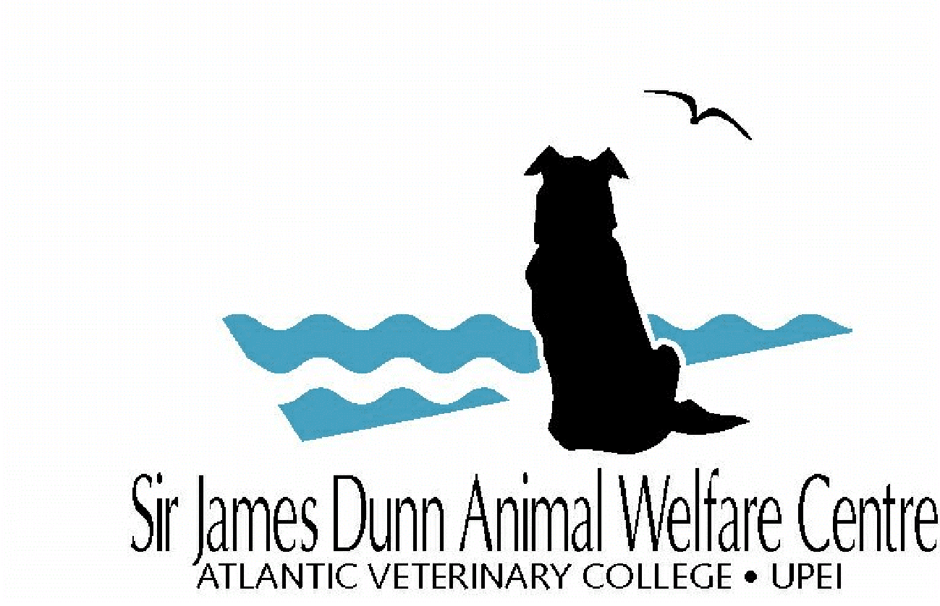**SJDAWC Progress / Final Report Form**

Research / Service / Integrated Projects

|  |  |
| --- | --- |
| **For office use only**  **Date received:** | Select date |

Revised Form: July 18, 2024

**Instructions:**

* **Progress Reports:** Please include information since your last progress report (or start of the project if this is your first report).
* **Final Reports:** Please include information for the duration of the project. For research/integrated final reports, we expect that the project has been completed, including all data collection, analysis, and manuscript preparation/submission.
* Submit an electronic Word copy to [animalwelfare@upei.ca](mailto:animalwelfare@upei.ca).
* Please respect the deadline, failure to do so will jeopardize future SJDAWC funding.

|  |  |  |  |  |  |  |  |  |  |  |  |  |
| --- | --- | --- | --- | --- | --- | --- | --- | --- | --- | --- | --- | --- |
| **Type of Report:** | | Select one | | | **Type of Project:** | | | Select one | | | | |
|  | | | | | | | | | | | | |
| **Section 1: Project Title** | | | | | | | | | | | | |
| Enter text | | | | | | | | | | | | |
|  | | | | | | | | | | | | |
| **Section 2: Project Team** | | | | | | | | | | | | |
| **PI:** | Enter text | | | **Dept:** | | Enter text | | | **Email:** | Enter text | | |
| **Co-PI:** | Enter text | | | **Dept /**  **Organization:** | | Enter text | | | **Email:** | Enter text | | |
| **Co-PI:** | Enter text | | | **Dept /**  **Organization:** | | Enter text | | | **Email:** | Enter text | | |
| **Co-PI:** | Enter text | | | **Dept /**  **Organization:** | | Enter text | | | **Email:** | Enter text | | |
| **Co-PI:** | Enter text | | | **Dept /**  **Organization:** | | Enter text | | | **Email:** | Enter text | | |
| **Co-PI:** | Enter text | | | **Dept /**  **Organization:** | | Enter text | | | **Email:** | Enter text | | |
| **Co-PI:** | Enter text | | | **Dept /**  **Organization:** | | Enter text | | | **Email:** | Enter text | | |
|  | | | | | | | | | | | | |
| **Section 3: Progress Towards Objectives** | | | | | | | | | | | | |
| **Project Milestones:** Provide an update on the milestones completed for each of the objectives listed in the original grant application. This should include a description of what has been completed for each objective, as well as a timeline of when milestones were met in comparison to was expected. | | | | | | | | | | | | |
| Enter text | | | | | | | | | | | | |
| **Service Projects:** Please specify the number of animals that received care. | | | | | | | | | | | | |
| Enter text | | | | | | | | | | | | |
|  | | | | | | | | | | | | |
| **Section 4: Problems Encountered and Project Changes** | | | | | | | | | | | | |
| **Have any major problems been encountered with the project?** | | | | | | | | | | | | Select one |
| If yes, please describe the problems encountered and the steps taken to resolve them. | | | | | | | | | | | | |
| Enter text | | | | | | | | | | | | |
| **Have any changes been made to the original objectives?** | | | | | | | | | | | | Select one |
| If yes, please provide a detailed description, and justification for, any deviations from the original objectives listed in the grant application. If the changes in objectives affect the original scope of the project, they will be subject to review by the SJDAWC Management Board. | | | | | | | | | | | | |
| Enter text | | | | | | | | | | | | |
| **Have any changes been made to the original timeline?** | | | | | | | | | | | | Select one |
| If yes, please provide a revised timeline including new milestones for each objective. If the new timeline goes beyond the original grant end-date, please see **Section 9** for information about extensions. | | | | | | | | | | | | |
| Enter text | | | | | | | | | | | | |
| **Have any changes been made to the original research team?** | | | | | | | | | | | | Select one |
| If yes, please provide any changes to the team, including changes in contributions from specific team members. | | | | | | | | | | | | |
| Enter text | | | | | | | | | | | | |
| **Do you need to make any major changes to the original budget?** | | | | | | | | | | | | Select one |
| If yes, provide justification for the revised budget and complete the financial statement in **Section 10**. If this is an integrated project, then both the service and research sections will need to be completed. | | | | | | | | | | | | |
| Enter text | | | | | | | | | | | | |
|  | | | | | | | | | | | | |
| **Section 5: Dissemination of Research Results** | | | | | | | | | | | | |
| **Citations:** Provide citations for any publications, conference presentations, workshops, and teaching opportunities given this past year arising from the project supported by the grant. For publications, specify whether submitted, accepted, or published.  **Please follow examples below for citations:**  **Publication:** DOE J, FARMER S, POPE T. 2024. Dairy housing on Prince Edward Island Canada. *Journal of Dairy Science. 106(5):3548-3558.* [*https://doi.org/10.3168/jds.2024-22742*](https://doi.org/10.3168/jds.2024-22742)    **Presentation:** FARMER S. 2024. Swine housing on Prince Edward Island Canada. Manitoba Swine Seminar. Winnipeg, Manitoba. Oral presentation. (or Poster presentation or Workshop.) | | | | | | | | | | | | |
| Enter text | | | | | | | | | | | | |
| **Images:** Do you have any images from your project that you are willing to submit with your report for the SJDAWC to share through our newsletters, social media, or website? | | | | | | | | | | | | Select one |
| If yes, please attach images to the end of this report or email them to [animalwelfare@upei.ca](mailto:animalwelfare@upei.ca). Please provide location, photo credit, and/or names of people in picture from left to right. | | | | | | | | | | | | |
|  | | | | | | | | | | | | |
| **Section 6: Project Budget** | | | | | | | | | | | | |
| **Total original budget:** | | | $ Enter number | | | | **Status of remaining budget:** | | | | $ Enter number | |
| **Date (or expected date) of project completion:** | | | | | Select date | | | | | | | |
|  | | | | | | | | | | | | |
| **Section 7: Supplementary Project Funding** | | | | | | | | | | | | |
| **Did you receive any additional supplementary project funding this current year that was not included in your original budget?** | | | | | | | | | | | | Select one |
| If yes, please list the year, who the funds were received from and the amount. | | | | | | | | | | | | |
| Enter text | | | | | | | | | | | | |
|  | | | | | | | | | | | | |
| **Section 8: Lay Summary (Final Reports only)** | | | | | | | | | | | | |
| **Final Report:** If this is your Final Report, please provide a lay summary (maximum 150 words) outlining the summarized results of your project and their relevance to animal welfare. The summary must be written so that a lay audience can understand your project, as it will be used for public dissemination. Please include information our donors will understand and appreciate how their funds have contributed to advancing animal welfare through your project. | | | | | | | | | | | | |
| Enter text | | | | | | | | | | | | |
|  | | | | | | | | | | | | |
| **Section 9: Extensions (Two types)** | | | | | | | | | | | | |

|  |
| --- |
| **A. 1-year extension of grant:** In some circumstances, an extension of up to one year after the end date of the grant is allowable. Requests to extend the project must be included in this form no later than 2 months before the grant expires. Extension requests may be subject to SJDAWC Management Board approval. If an extension is granted, a progress report will be due in lieu of a final report. Final reports will be due once the project is completed. Any residual funds left in the account after the extension will be returned to the SJDAWC. If a second grant extension is required, the same process is followed as above. |

|  |  |
| --- | --- |
| **Do you request a 1-year extension for this grant?** | Select one |
| If yes, please provide…   1. A detailed justification for the extension 2. A revised timeline (if already stated in Section 4, then indicate **see Section 4 above**) 3. Complete the financial statement in **Section 10**. If this is an integrated project, then both the service and research sections will need to be completed. | |
| Enter text | |
| **B. Information dissemination extension:** It is possible to extend funds for publication costs up to two years after the end date of the grant. Requests to extend funds for publication costs must be included in this report no later than 2 months before the grant expires. Extension requests may be subject to SJDAWC Management Board approval. Final reports are still due by the original due date. Any residual funds left in the account after the two-year extension will be returned to the SJDAWC; no further extensions will be given. | |
| **Do you request an extension for information dissemination?** | Select one |
| If yes, please provide…   1. A detailed justification for the extension 2. The costs originally allocated in the budget for information dissemination 3. An anticipated timeline for submission of publications. | |
| Enter text | |
|  | |
| **Section 10: Financial Statement** | |
| Complete this section only if you need to include the financial statement as indicated in **Sections 4 and/or 9**. | |

|  |  |  |  |  |
| --- | --- | --- | --- | --- |
| **SJDAWC budget item**  **(SERVICE BUDGET/EXPENSES)** | **Original Budget** | **Actual Expenses** | **Remaining Expenses** | **Proposed Budget (if applicable)** |
| Student stipend and tuition | $ Enter number | $ Enter number | $ Enter number | $ Enter number |
| Other personnel | $ Enter number | $ Enter number | $ Enter number | $ Enter number |
| Animal care and use | $ Enter number | $ Enter number | $ Enter number | $ Enter number |
| Materials and supplies | $ Enter number | $ Enter number | $ Enter number | $ Enter number |
| Equipment | $ Enter number | $ Enter number | $ Enter number | $ Enter number |
| Project travel | $ Enter number | $ Enter number | $ Enter number | $ Enter number |
| Data analysis | $ Enter number | $ Enter number | $ Enter number | $ Enter number |
| Information dissemination | $ Enter number | $ Enter number | $ Enter number | $ Enter number |
| Travel for scientific meeting | $ Enter number | $ Enter number | $ Enter number | $ Enter number |
| Other costs | $ Enter number | $ Enter number | $ Enter number | $ Enter number |
| **TOTAL**  **(SERVICE BUDGET/EXPENSES)** | **$** **Enter number** | **$** **Enter number** | **$** **Enter number** | **$** **Enter number** |
| **SJDAWC budget item**  **(RESEARCH BUDGET/EXPENSES)** | **Original Budget** | **Actual Expenses** | **Remaining Expenses** | **Proposed Budget**  **(if applicable)** |
| Student stipend and tuition | $ Enter number | $ Enter number | $ Enter number | $ Enter number |
| Other personnel | $ Enter number | $ Enter number | $ Enter number | $ Enter number |
| Animal care and use | $ Enter number | $ Enter number | $ Enter number | $ Enter number |
| Materials and supplies | $ Enter number | $ Enter number | $ Enter number | $ Enter number |
| Equipment | $ Enter number | $ Enter number | $ Enter number | $ Enter number |
| Project travel | $ Enter number | $ Enter number | $ Enter number | $ Enter number |
| Data analysis | $ Enter number | $ Enter number | $ Enter number | $ Enter number |
| Information dissemination | $ Enter number | $ Enter number | $ Enter number | $ Enter number |
| Travel for scientific meeting | $ Enter number | $ Enter number | $ Enter number | $ Enter number |
| Other costs | $ Enter number | $ Enter number | $ Enter number | $ Enter number |
| **TOTAL**  **(RESARCH BUDGET/EXPENSES)** | **$** **Enter number** | **$** **Enter number** | **$** **Enter number** | **$** **Enter number** |
| **SJDAWC**  **(TOTAL BUDGET/ EXPENSES)** | **$** **Enter number** | **$** **Enter number** | **$** **Enter number** | **$** **Enter number** |

|  |
| --- |
| **Please remember to acknowledge support of the Sir James Dunn Animal Welfare Centre**  **And all funding partners in any resulting publications.** |