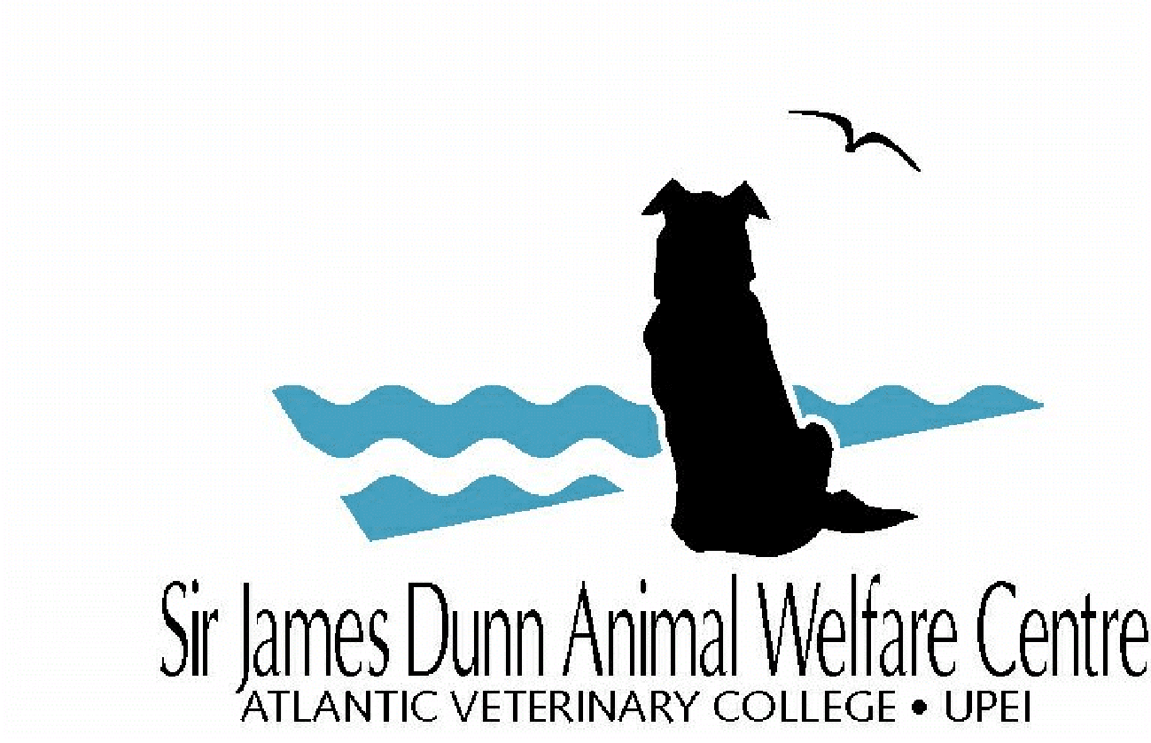

SJDAWC Notice of Intent Form

For office use only
Date Received:

Instructions:
- Deadline (all project types): September 14, 2023, 3:00 p.m.
- Submit an electronic copy to animalwelfare@upei.ca

Project type: (place an “x” in one box only) | ☐ Research Project ☐ Service Project ☐ Integrated Project
Application: (place an “x” in one box only) | ☐ New Funding ☐ Renewed Funding

- Project title
- Principal Investigator
Name: |  | Department: |  | Email:

Please list names of other co-investigators if known.
Name:
Name:
Name:
Name:

- Notice of Intent
NOIs should be no more than 250 words and use language suitable for academics from a range of disciplines. The NOI should briefly summarize: 1) the overall project goal(s) and supporting objectives, and 2) the general approach/methodology that would be used to accomplish the project goal(s), and 3) the relevance of the project to animal welfare.

