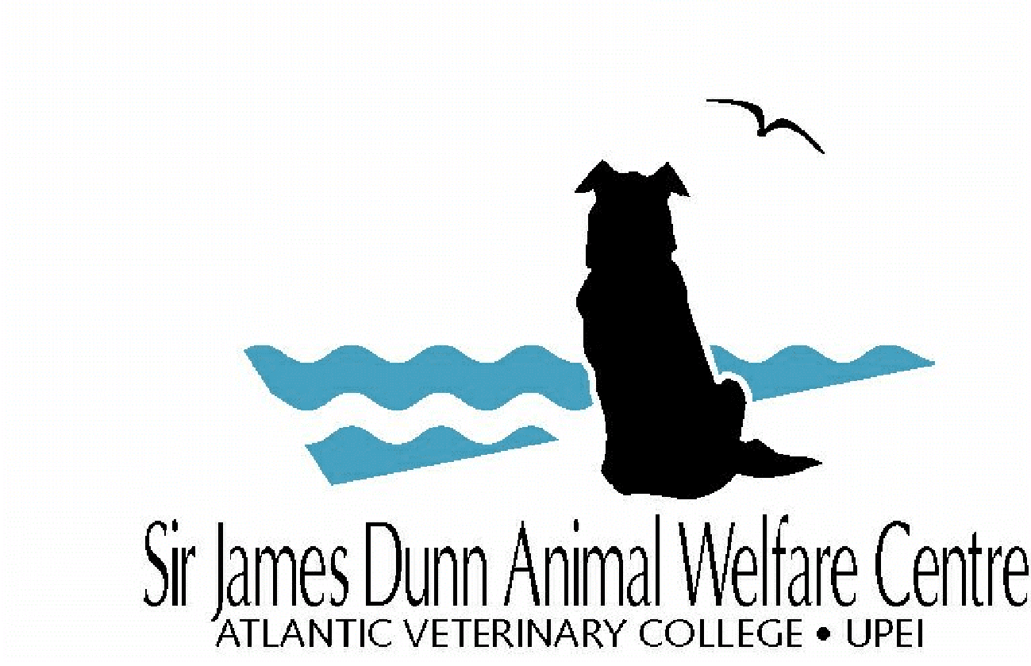

SJDAWC Application Form
Service Grants

For office use only
Date Received:

Instructions:
- Application Deadline (all project types): October 19, 2023, 3:00 p.m.
- Submit two electronic copies to animalwelfare@upei.ca:
- One copy in the Word application form.
- One copy with signatures (electronic signatures or printed, scanned, and emailed).
You will receive a confirmation email within two business days after submitting the application. If you do not receive a confirmation email, please follow up by email.

Application: (place an “x” in one box only) | ☐ New Funding ☐ Renewed Funding

- Project title
- Project Team
Principal investigator: |  | Department: |  | Email:
Co-Investigator: |  | Department / Organization: |  | Email:
Co-Investigator: |  | Department /  Organization: |  | Email:
Co-Investigator: |  | Department / Organization: |  | Email:
Co-Investigator: |  | Department /  Organization: |  | Email:

- Project information
Start date*: |  | End date:
Total budget:
*Start dates should be March 1st of the given year of the award or anytime later, see guidelines for more information
- Signatures
Principal Investigator: ______________________________________ Date: Click here to enter a date.

Department Chair: ______________________________________ Date: Click here to enter a date.

Veterinary Teaching Hospital (VTH) Director or designate (if any project involves using any hospital resources)
______________________________________ Date: Click here to enter a date.

- References
Project Summaries should be no more than 250 words and use language suitable for a layperson. The summary should focus on the overall project goal(s) and supporting objectives, plans to accomplish the project goal(s), and relevance of the project to animal welfare.

- Proposal
Proposals should be no more than 5 pages and succinctly describe your proposed project, including the following elements (see Guidelines for details on each section):
Present state of knowledge:

Project goal(s) and supporting objectives:

Significance to animal welfare:

Project design and methodology:

Project timeline:

Mitigating animal suffering or harm (optional):

Plans for training and information dissemination:

Expertise and roles of project team:

Plans for community engagement:

Outcomes from previous SJDAWC-funded projects (1 extra page for a total of 6 pages):
New for 2024: Please fill this section out if you have had a completed SJDAWC grant in the past.

- References

- SJDAWC Budget and Justification
Please fill out table for your project. Budgets must not exceed $25,000 total for project of up to 1 year (renewable).

SJDAWC Budget item | Year 1
Student stipend and tuition
Other Personnel
Animal care and use
Materials and supplies
Equipment
Project travel
Data analysis
Information dissemination
Travel for scientific meetings
Other costs
SJDAWC Total budget for year

SJDAWC Budget Justification:
Please provide details for each line item in the above budget.

Student stipend and tuition
Other Personnel
Animal care and use
Materials and supplies
Equipment
Project travel
Data analysis
Information dissemination
Travel for meetings
Other costs

Has funding been applied for or secured from other sources?
Yes ☐ - If yes, please complete section 9. Other Funding Budget and Justification
No ☐ - If no, do not complete section 9.

- Other Funding Budget and Justification (only complete if you applied or secured funding from other sources)
Other Funding Budget item | Year 1
Student stipend and tuition
Other Personnel
Animal care and use
Materials and supplies
Equipment
Project travel
Data analysis
Information dissemination
Travel for scientific meetings
Other costs
Total Other Funding budget for year

Total budget amount from Sections 8. and 9. (SJDAWC and other funding sources)?

