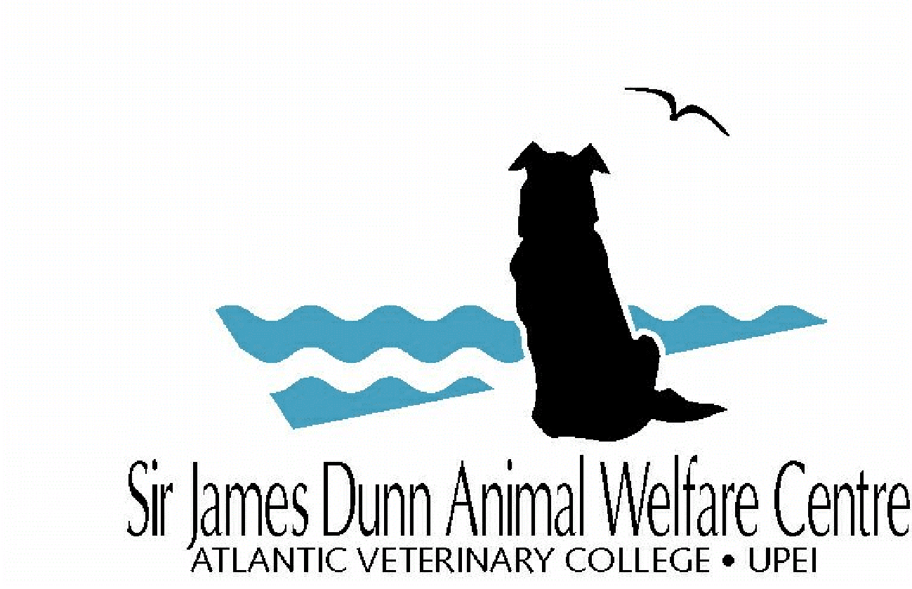

SJDAWC Application Form

For office use only
Date Received:

Instructions:
- Application Deadline (all project types): November 4, 2021, 5pm
- Submit two electronic copies to animalwelfare@upei.ca:
- One copy in the Word application form.
- One copy with signatures (electronic signatures or printed, scanned, and emailed).
You will receive a confirmation email within two business days after submitting the application. If you do not receive a confirmation email, please follow up by email.

Project type: (place an “x” in one box only) | ☐ Research Project ☐ Service Project ☐ Integrated Project
Application: (place an “x” in one box only) | ☐ New Funding ☐ Renewed Funding

- Project title
- Project Team
Principal investigator: |  | Department: |  | Email:
Co-Investigator: |  | Department / Organization: |  | Email:
Co-Investigator: |  | Department /  Organization: |  | Email:
Co-Investigator: |  | Department / Organization: |  | Email:
Co-Investigator: |  | Department /  Organization: |  | Email:

- Project information
Start date: |  | End date:
Total budget:

- Signatures
Principal Investigator: ______________________________________ Date: Click here to enter a date.

Department Chair: ______________________________________ Date: Click here to enter a date.

Associate Dean of Clinical & Professional Programming or designate (if any project involves using any hospital resources)
______________________________________ Date: Click here to enter a date.

- Project Summary
Project Summaries should be no more than 250 words and use language suitable for a layperson. The summary should focus on the overall project goal(s) and supporting objectives, plans to accomplish the project goal(s), and relevance of the project to animal welfare.

- Proposal
Proposals should be no more than 5 pages and succinctly describe your proposed project, including the following elements (see Guidelines for details on each section):
Present state of knowledge:

Project goal(s) and supporting objectives:

Significance to animal welfare:

Project design and methodology used to assess animal welfare:

Project timeline:

Mitigating animal suffering or harm (optional):

Plans for training and information dissemination:

Expertise and roles of investigators:

Provide at least two names and email addresses for external reviewers (Research and Integrated projects only):

Plans for community engagement (Service and Integrated projects only):

Previous outcomes from renewed projects (Service and Integrated Projects only; extra 1-page allowed):

- References
- SJDAWC Budget and Justification
SJDAWC Budget item | Year 1 | Year 2 | Year 3
Student stipend and tuition
Other Personnel
Animal care and use
Materials and supplies
Equipment
Project travel
Data analysis
Information dissemination
Travel for scientific meeting
Other costs
SJDAWC Total budget for each year

Total amount requesting from SJDAWC (per table above)?

Has funding been applied for or secured from other sources?
Yes ☐ - If yes, please complete section 9. Other Funding Budget and Justification
No ☐ - If no, do not complete section 9.

SJDAWC Budget Justification:
Please provide details for each line item in the above budget.

- Other Funding Budget and Justification (only complete if you applied or secured funding from other sources)
Other Funding Budget item | Year 1 | Year 2 | Year 3
Student stipend and tuition
Other Personnel
Animal care and use
Materials and supplies
Equipment
Project travel
Data analysis
Information dissemination
Travel for scientific meeting
Other costs
Other Funding Total budget

Total amount applied or secured from other funding sources (per table above)?

Total budget amount from Sections 8. and 9. (SJDAWC and other funding sources)?

