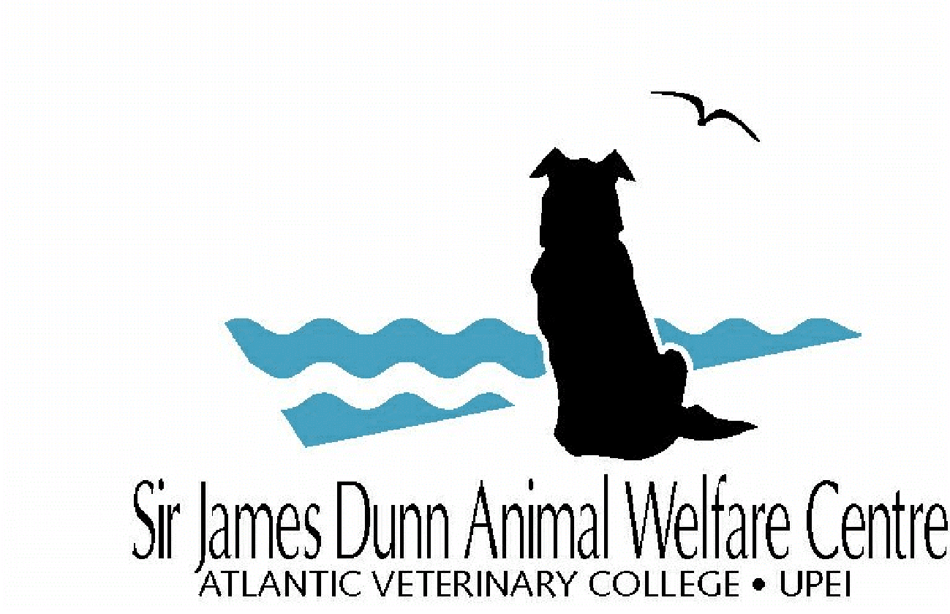

SJDAWC Notice of Intent Form

For office use only
Date Received:

Instructions:
- Deadline (all project types - this is optional to submit): October 15, 2020, 5pm
- Submit an electronic copy to kproudfoot@upei.ca

Project type: (place an “x” in one box only) | ☐ Research Project ☐ Service Project ☐ Integrated Project
Application: (place an “x” in one box only) | ☐ New Funding ☐ Renewed Funding

- Project title
- Project team
Principal Investigator: |  | Department:
Co-Investigator: |  | Dept/Organization:
Co-Investigator: |  | Dept/Organization:
Co-Investigator: |  | Dept/Organization:

- Project Summary
Project Summaries should be no more than 250 words and use language suitable for a layperson. The summary should focus on the overall project goal(s) and supporting objectives, plans to accomplish the project goal(s), and relevance of the project to animal welfare.

