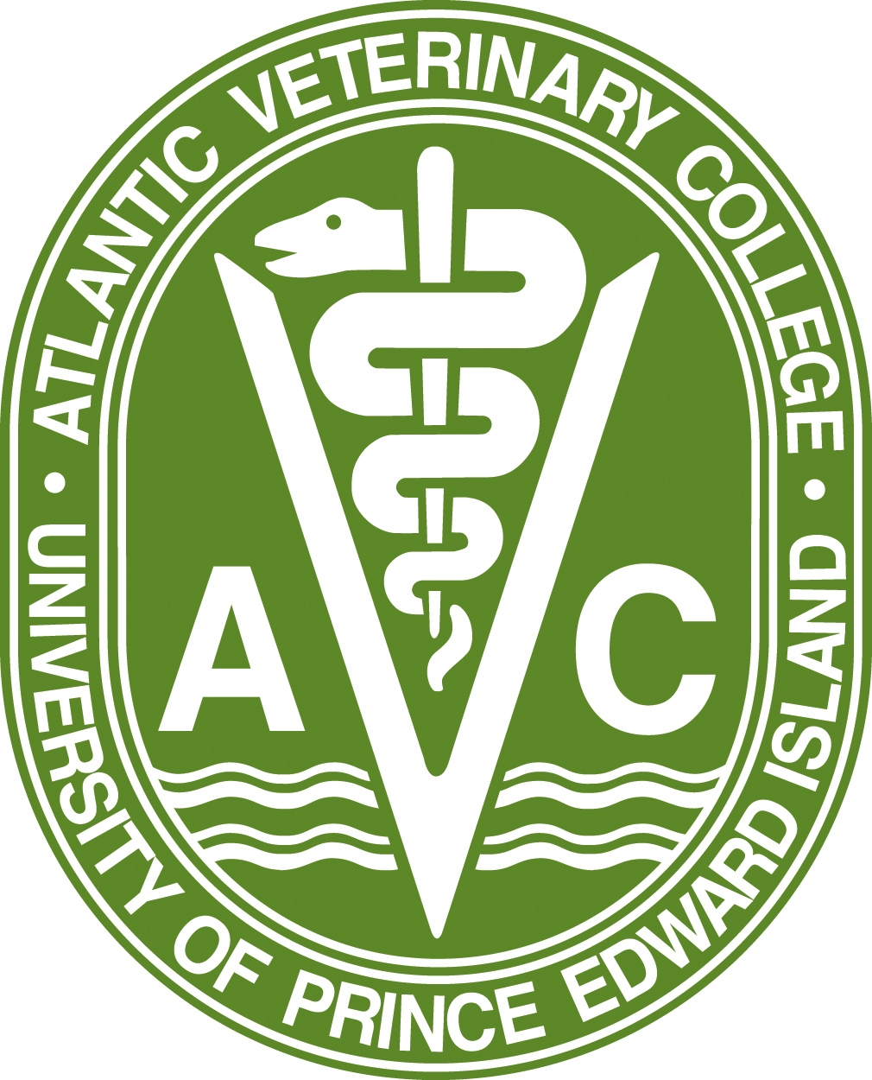


Atlantic Award of Excellence in
Veterinary Medicine and Animal Care

2021 NOMINATION FORM

Nominations received for the 2021 Atlantic Award of Excellence in Veterinary Medicine and Animal Care will be evaluated based solely on the information provided.

Nominations can be completed by filling out the attached form and mailing a printed copy, along with letters of support, to the address indicated below.

All criteria must be met and accompanied by any relevant documentation describing the work and achievements of the nominee, which would qualify the nominee for the award. Additional documentation should be as concise as possible.

Nominations must be received by mail to Atlantic Veterinary College by Friday, February 11, 2022:

Atlantic Award of Excellence Nomination Committee
c/o Dean’s Office, Atlantic Veterinary College

550 University Avenue, Charlottetown, PEI C1A 4P3

Or by email to:

avcspecialevents@upei.ca

Atlantic Award of Excellence in Veterinary
Medicine and Animal Care

2021 NOMINATION FORM

Information about the Nominee:

Nominee’s name:

Nominee’s complete address:

Telephone:

Facsimile: E-mail:

Nominee’s name

is submitted for consideration for the 2021 Atlantic Award of Excellence in Veterinary Medicine and Animal Care

Nominator

Nominator’s Title

Address

Nominator’s Telephone

Facsimile

E-mail

Why do you feel this veterinarian is a deserving recipient of this Award?

Areas for consideration could include:
a.) work-related achievements (the practice and teaching of veterinary medicine or research)
b.) service to the veterinary profession (public education, participation in associations, societies, institutions)
c.) service to the community (volunteer work in the community, service clubs, charitable organizations; participation in commissions, boards, task forces; participation in government administration, and other paid/unpaid work)
d.) personal and general information (education; publications; directorships; honours and decorations); other relevant information

Additional support material

Please include a current CV of your nominee with this form.

